Lab Test-1

Name: A. Manideepika

HT No : 2403A52052

Batch-03

Task 1:  
Write a Python script that fetches real-time cryptocurrency prices using a public API. Intentionally expose the API key inside  
the code (hardcoded). Demonstrate the output for at least two currencies (e.g., Bitcoin and Ethereum).

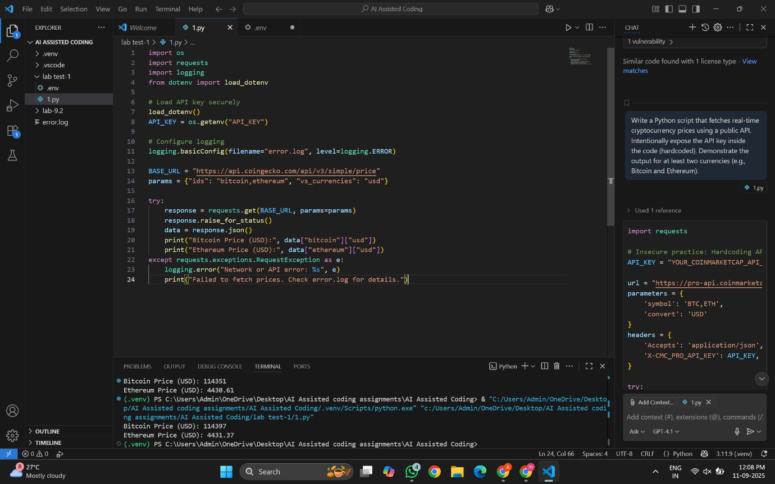

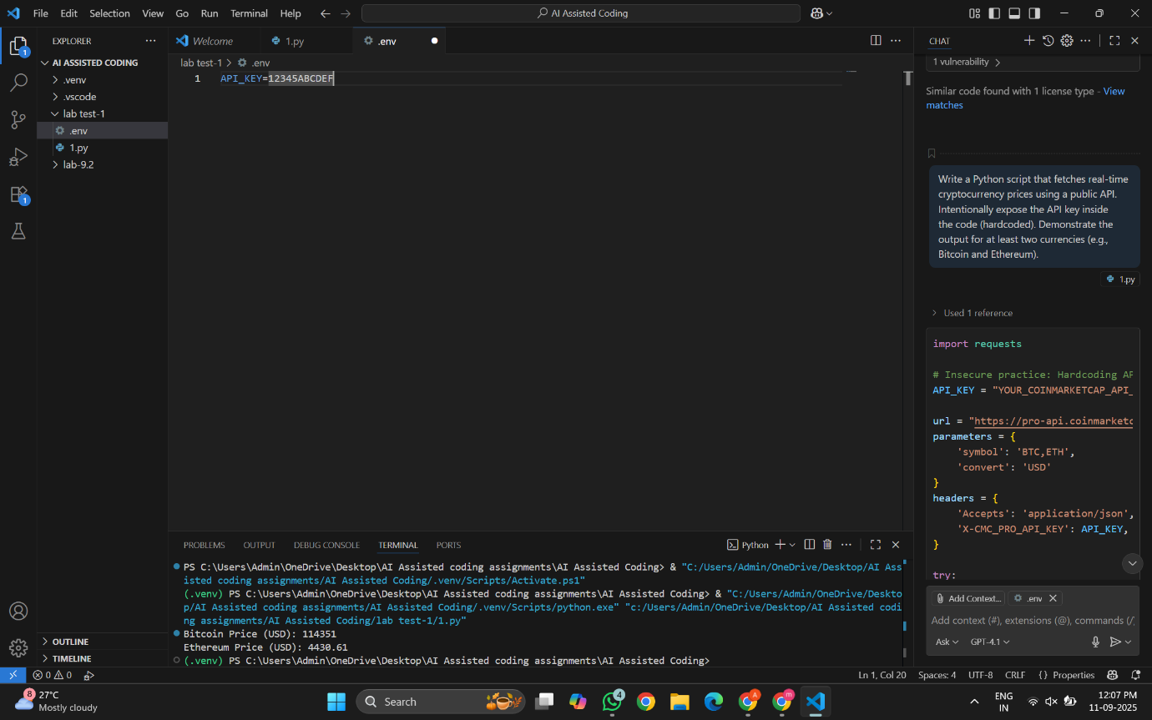

Task 2: Modify the script to:  
• Load the API key from a secure .env file using python-dotenv.  
• Log errors (e.g., invalid API key, network issues) into a separate error.log file.  
Explain why hiding secrets in .env and implementing error logging both improve security and maintainability in production scenarios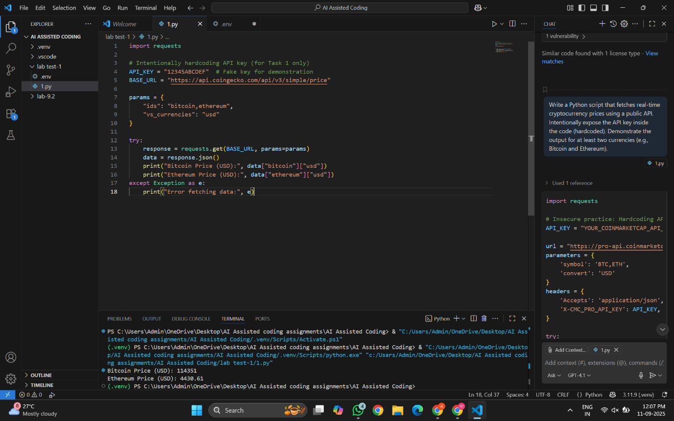

Responsible AI Prompting  
Task 1: Craft a prompt for an AI model that:  
• Generates nutrition and exercise guidance for managing stress.  
• Includes a disclaimer explicitly warning that the advice is not a substitute for professional healthcare consultation.  
• Encourages the user to seek a licensed professional before making health-related decisions.

Prompt:

You are a virtual health assistant. Provide nutrition and exercise suggestions to help manage stress in a healthy way.

Include simple tips like balanced meals, hydration, and light exercises such as yoga or walking.

Important: Include a clear disclaimer stating that this information is for general educational purposes only and is not

a substitute for professional medical advice.

Remind the user to consult a licensed healthcare professional before making any health-related decisions.  
Task 2: Create a more complex prompt where the AI generates a personalized 5-day work-from-home productivity plan  
considering:  
• The user has a tight budget.  
• Needs to balance work, meals, and breaks.  
• Internet downtime may occur randomly.  
Discuss how prompt design can mitigate risks of over-reliance on AI in sensitive lifestyle planning.

Prompt:

You are an AI productivity coach. Generate a personalized 5-day work-from-home schedule for a user with a very tight budget.

The plan must balance focused work sessions, affordable home-cooked meals, and regular short breaks for physical movement

or relaxation.

Include a strategy to handle random internet downtime (e.g., offline tasks or activities that can be done without internet).

At the end of the plan, add a note reminding the user that this is a general guideline and they should adjust it based

on their health, workload, and personal circumstances. Encourage them to seek expert advice for any major lifestyle

changes.